**Problem Statement: Inter-Process Communication (IPC) using Pipes, Shared Memory, and Message Queues**

**Design and implement efficient and reliable inter-process communication (IPC) mechanisms using pipes, shared memory, and message queues in C to facilitate data exchange and synchronization between multiple processes within a single system.**

**Specific Requirements:**

**Pipe: Create and manage unidirectional and bidirectional pipes for simple data transfer between related processes.**

**Shared Memory: Allocate and manage shared memory segments for efficient data sharing between multiple processes.**

**Message Queues: Create and utilize message queues for asynchronous communication and data exchange with message prioritization.**

**Synchronization: Implement appropriate synchronization mechanisms (e.g., semaphores, mutexes) to coordinate access to shared resources and prevent race conditions.**

**Error Handling: Incorporate robust error handling to manage potential IPC failures and resource leaks.**

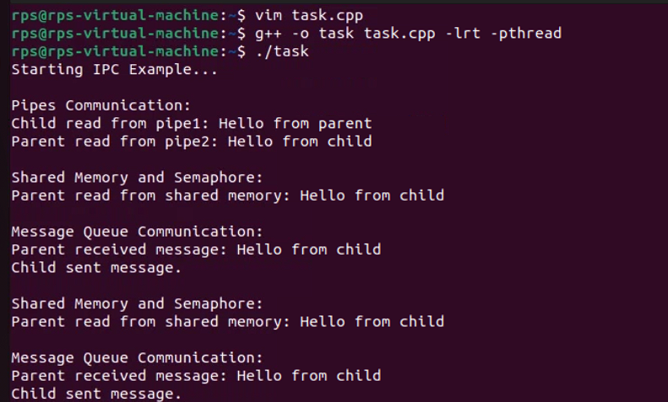

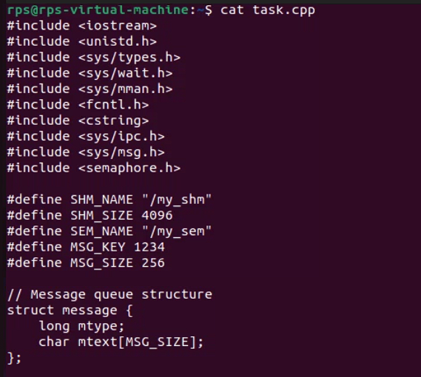

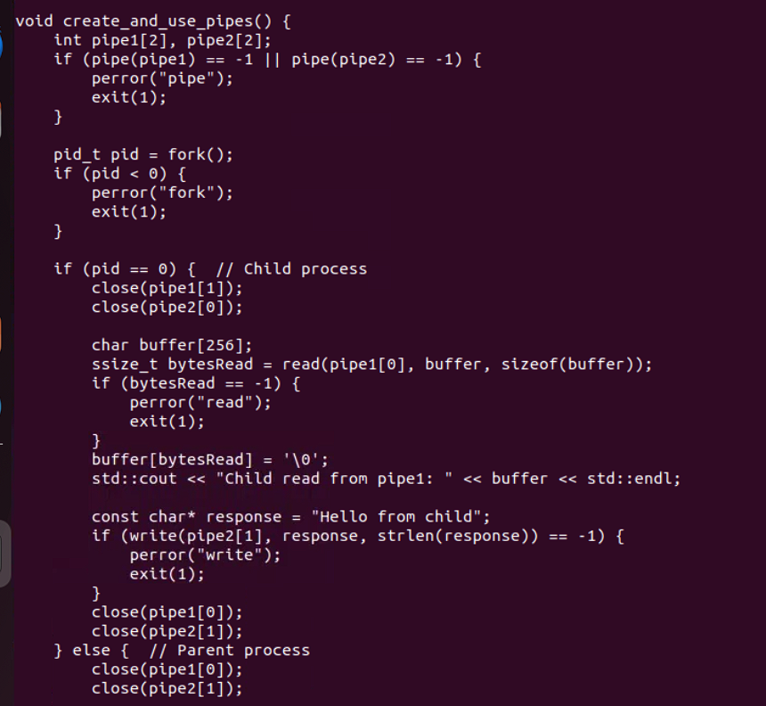

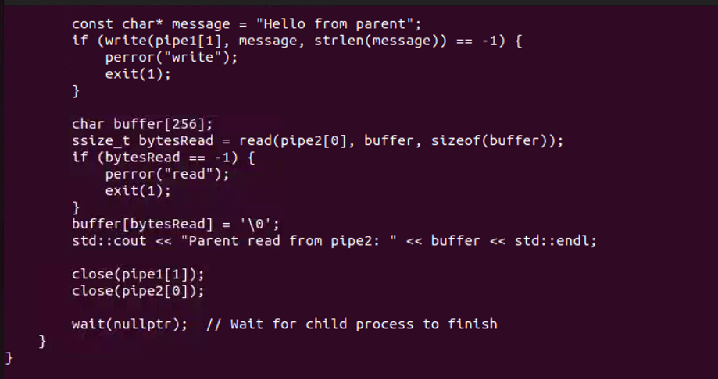

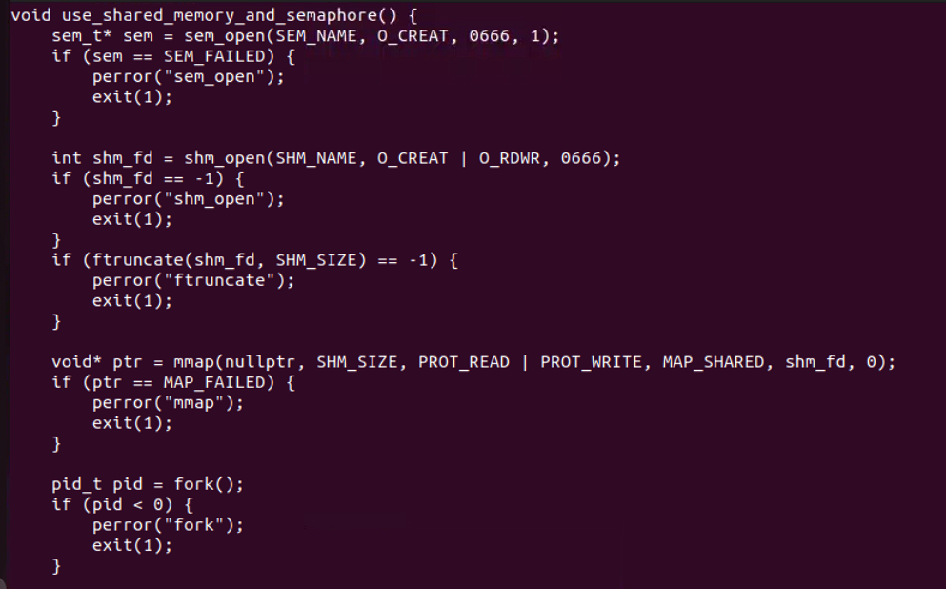

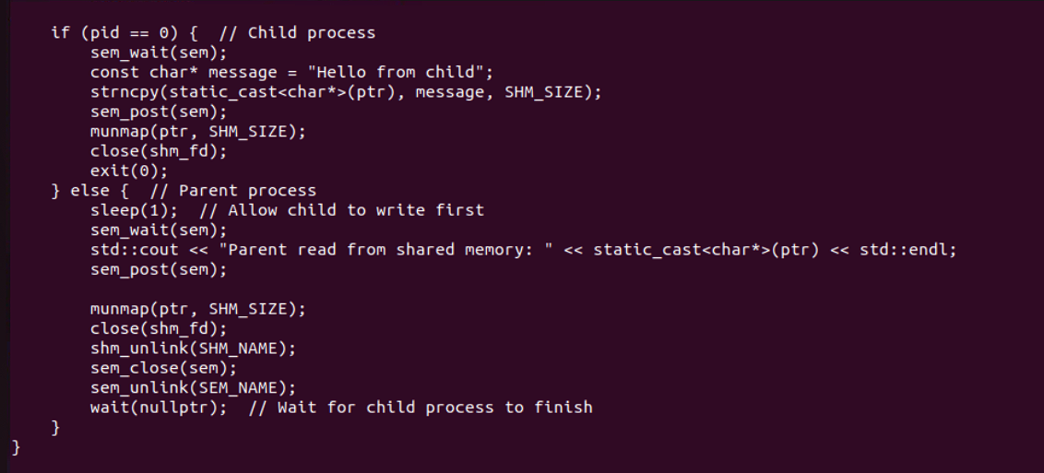

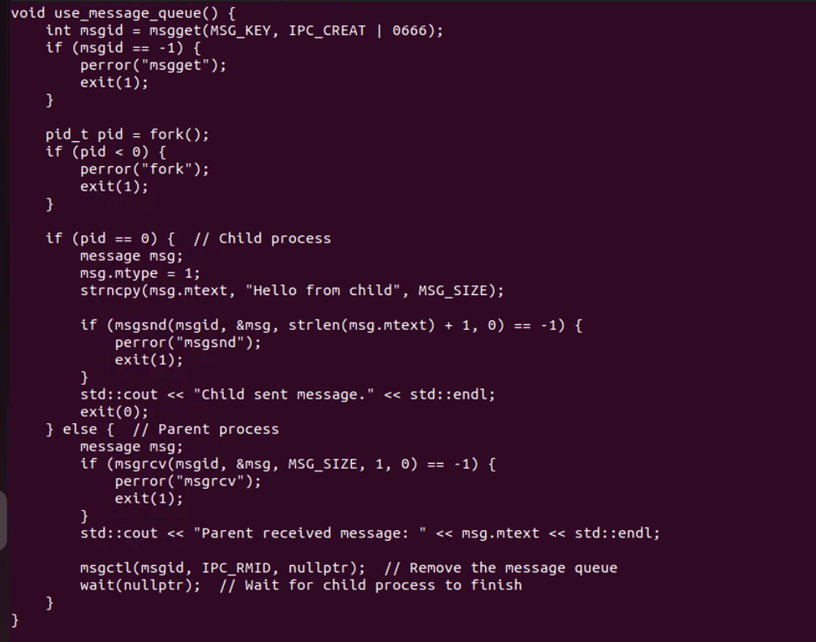

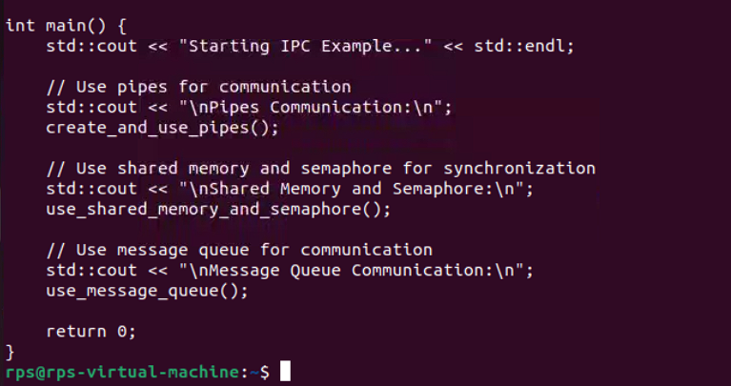

**Objective Questions (15)**

**What is the correct syntax for declaring a constant integer in C++?**

a) const int x;

b) int const x;

c) const int x = 10;

d) Both a and c

**Answer:** D

**What is the output of the following code?**

#include <iostream>

int main() {

int x = 10;

std::cout << (x > 5 ? x : 5);

return 0;

}

a) 5

b) 10

c) 15

d) 0

**Answer:** B

**Which of the following access specifiers allows access only within the class itself and its derived classes?**

a) public

b) private

c) protected

d) friend

**Answer:** C

**What will be the output of the following code?**

#include <iostream>

class Base {

public:

virtual void show() { std::cout << "Base"; }

};

class Derived : public Base {

public:

void show() override { std::cout << "Derived"; }

};

int main() {

Base* b = new Derived();

b->show();

delete b;

return 0;

}

a) Base

b) Derived

c) BaseDerived

d) Compilation error

**Answer:** B

**What is the output of the following code?**

#include <iostream>

int main() {

int arr[3] = {1, 2, 3};

std::cout << arr[2];

return 0;

}

a) 1

b) 2

c) 3

d) Compilation error

**Answer:** C

**Which keyword is used to prevent a class from being instantiated?**

a) final

b) abstract

c) static

d) virtual

**Answer:** B

**What will be the output of the following code?**

#include <iostream>

int main() {

int x = 5;

int& y = x;

y = 10;

std::cout << x;

return 0;

}

a) 5

b) 10

c) 15

d) Compilation error

**Answer:** B

**Which of the following is the correct way to declare a pure virtual function in C++?**

a) virtual void func() = 0;

b) virtual void func();

c) void func() = 0;

d) pure virtual void func();

**Answer:** A

**What is the output of the following code?**

#include <iostream>

int main() {

const char* str = "Hello";

str[0] = 'J';

std::cout << str;

return 0;

}

a) Hello

b) Jello

c) Compilation error

d) Runtime error

**Answer:** C

**Which operator is used to access the members of a class through a pointer?**

a) ->

b) .

c) *

d) ::

**Answer:** A

**What is the result of the following code?**

#include <iostream>

int main() {

int a = 5;

int b = 10;

int c = a + b;

std::cout << c;

return 0;

}

a) 5

b) 10

c) 15

d) Compilation error

**Answer:** C

**Which of the following is used to define a constant value in C++?**

a) const

b) static

c) final

d) volatile

**Answer:** A

**What will be the output of the following code?**

#include <iostream>

int main() {

int x = 10;

std::cout << ++x * 2;

return 0;

}

a) 20

b) 22

c) 30

d) 40

**Answer:** B

**Which type of inheritance is also known as multiple inheritance in C++?**

a) Single Inheritance

b) Multi-level Inheritance

c) Hierarchical Inheritance

d) Diamond Inheritance

**Answer:** D

**What is the output of the following code?**

#include <iostream>

void func(int a, int b = 2) {

std::cout << a + b;

}

int main() {

func(3);

return 0;

}

a) 5

b) 3

c) 7

d) Compilation error

**Answer:** A